
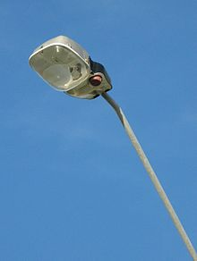
.
Enjoying Escombs’ streets safely.

- A new bus shelter.
- Introduce street lights along the black path.
- More dog fouling bins along the black path.
- Better barriers along the road path so the children are safer.
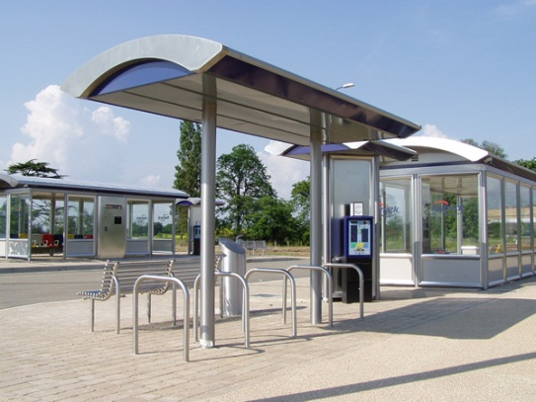
- Repave the entrance of the black path so it’s safer for scooters and bikes to ride along.
