Air Quality Street Survey

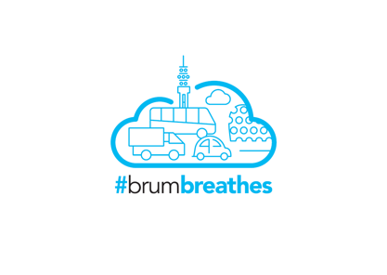

To find out more about air pollution and to input your local air quality data, follow the link below:
www.sustrans.org.uk/brum-breathes
Location: Date: Time:
Indicator | Rating |  |  | Score | Notes
 | 1 | 2 | 3
What is the traffic count?  (number of moving vehicles) | 0 moving vehicles | 6-10 moving vehicles | More than 10 moving vehicles
Are there a lot of idling cars? | 0 idling cars | 6-10 idling cars | More than 10 idling cars
Are public transport amenities present? How many within ½ mile of the area? | High presence – 4+ bus, train or tram stations nearby | Moderate presence – 1-3 bus, train or tram stations nearby | Low presence – no bus, train or tram stations nearby
How wide are pavements (usable by wheelchairs/mobility scooters)? | All pavements a minimum of 2m wide | Some pavements 2m wide | Few or no pavements 2m wide
What is the general height of buildings? | Few to no buildings are >20 feet | Some buildings are >20 feet | Most buildings are >20 feet
Are there gaps between buildings to allow air flow and dispersion of pollution particles? | Gaps are present between all buildings | Some gaps present between buildings | No gaps present, buildings close together, e.g. terraces
Where are trees located in reference to the road? | Trees mainly located between the pavement and the road | Mixture of trees located both on the furthest and closest side to the road | Trees mainly located on the furthest side of the pavement away from the road
Are there green spaces, e.g. parks, verges, off-road paths present? | Several green spaces | Moderate presence of green spaces | No or few green spaces
 |  |  | Total score (out of 24)

Air Quality Standard | Score
Good | 1-8
Moderate | 9-16
Poor | 17-24

Questions
- Are you concerned about the air quality score of your local area?

- Why do you think your local area has this particular air quality score?

- How can you reduce air pollution in your local area?

