
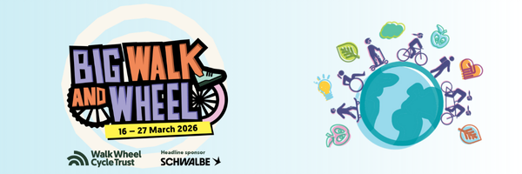
Dear [NAME],
Big Walk and Wheel is the UK’s largest inter-school walking, wheeling, scooting and cycling challenge. The challenge aims to get more children taking active travel to school to improve air quality in their neighbourhood and discover how these changes benefit their world.
On each day of the challenge, schools compete to see who can record the greatest proportion of their pupils taking active journeys to school. Big Walk and Wheel 2026 is taking place from 16 – 27 March.
I am writing to ask that [INSERT SCHOOL NAME] takes part in the challenge. It would be a fun way to encourage healthy habits, improve local air quality and help tackle climate change.
It’s free to take part. Participating schools could win some fantastic prizes and will also have access to a range of exciting resources, including curriculum linked lesson plans, and ideas to get all pupils involved.
You can find out more and register at www.bigwalkandwheel.org.uk.
Once registered you can download free educational resources and materials and a letter to parents inviting them to take part.
Why [INSERT SCHOOL NAME] should take part in Big Walk and Wheel.
Regular physical activity promotes good physical and mental health. Walking, wheeling, scooting or cycling is a great way for children to build physical activity into their daily routine. It helps children arrive more relaxed and alert, ready to start the day. It also helps reduce traffic congestion and improves air quality around the school.
A 2021 YouGov study showed nearly half of UK children worry about air pollution near their school. Children thought walking, wheeling, scooting or cycling was the best way to bring down these pollution levels. It also showed more children want to travel actively to school than currently do.
Just over 2.8million active journeys to 2,024 participating schools took place during the 2025 challenge, saving an estimated 2,880 tonnes of CO2 emissions if the journeys logged had otherwise been made by car.

[INSERT YOUR OWN REASONS FOR WANTING TO TAKE PART]
I really hope our school can take part this year! I am really excited about the positive difference our school could make.
Kind regards,
[NAME]

